

**Rubber and foam material analysis for Abaqus modelling**

|  |  |  |  |
| --- | --- | --- | --- |
| ORIGINATOR: |  | DATE |  |
| Yu Luan |  | 05-08-2016 |  |
| Last changed by: |  |  |  |
|  |  |  |  |
| Reviewed by: |  |  |  |
|  |  |  |  |



|  |  |  |  |  |
| --- | --- | --- | --- | --- |
| Document Revision History | | | | |
| Change  Order  Type & # | REV | Effectivity  Date (DMY) | Change  Owner | Change Description |
|  |  | 05-08-2016 | Yu Luan | Document started |
|  |  |  |  |  |
|  |  |  |  |  |
|  |  |  |  |  |
|  |  |  |  |  |
|  |  |  |  |  |
|  |  |  |  |  |
|  |  |  |  |  |
|  |  |  |  |  |
|  |  |  |  |  |
|  |  |  |  |  |
|  |  |  |  |  |
|  |  |  |  |  |
|  |  |  |  |  |
|  |  |  |  |  |
|  |  |  |  |  |

Contents

Introduction 3

1. Rubber analysis by laboratory 3

1.1 Test methodology 3

1.1.1 Static Stress-Strain Tests 3

1.1.2 Research of the compressibility 3

1.1.3 Dynamic Tests 3

1.2 Test results 4

1.2.1 Quasi-static data: 4

1.2.2 Result of the determination coefficient: 4

1.2.3 Research of the compressibility 4

1.2.4 Dynamic data: 4

1.3 Transfer test data into Abaqus 6

2 Rubber analysis at GN 6

3 Foam analysis 8

3.1 Foam analysis by Laboratory 8

3.1.1 For dynamic vibration simulation 8

3.1.2 For impact simulation 9

3.1.3 Laboratory report 9

3.2 Foam analysis at GN 9

3.2.1 Experimental setup 9

3.2.2 Abaqus model - curve fitting 14

References 15

Appendices 15

# Introduction

Rubber and foam material properties have to be reliable in Abaqus simulation. The data sheet values are usually not precise, and therefore, we have to analyze the test object in a laboratory or by ourselves. In the following, rubber and foam analyzation procedures are introduced.

# Rubber analysis by laboratory

The rubber need to be analyzed for the static Stress-Strain as well as the dynamic shear modulus (G' and G'') and the compressibility. In the following, the test methodology and test result are taken from DIK report as an example (The DIK report can be found in the appendices). The analyzed data is then transferred to Abaqus database. The obtained material properties can be used in Abaqus modelling for both dynamic vibration models and impact models.

## Test methodology

### Static Stress-Strain Tests

Stress-strain test will be performed on rotational symmetric dumbbell specimens in

tension/compression under the following conditions:

Apparatus : Zwick 1445 universal testing machine

Strain : -20 to + 50 %, 3 cycles and

-30 to + 100 %, 3 cycles

Strain-rate : 100 % per minute

Temperature : 23°C±1°C

Statistics : 1 sample per strain range

The elongation was determined by non-contact optical pickup.

### Research of the compressibility

The compressive modulus represents a materials resistance to volume change when

subject to compression loading. It can be calculated from theses measurements by

applying the following formula: K=V0*(P/V) with known initial volume V0 of rubber and

known cross-section of the cylinder pressure A0 with P=F/A0 and V=h*A0.

The experiment consist of using a piston to compress samples in a cylinder machined to

within very low tolerances. The measurement is performed at room temperature using a

servo-hydraulic machine. The system test measures the change in height in relation to the

change in load.

Apparatus : MTS servo-hydraulic machine

Temperature : 24±4°C

Strain-rate : 0,05 mm per minute

Statistics : 3 sample

### Dynamic Tests

Dynamic tests will be carried out on stripes 40 x 10 x 2 mm in torsion under the following

conditions:

Apparatus : Rheometrics RDA II

Sweep : Combined frequency-temperature sweeps

Temperature : 20 °C to -80 °C, step 10 °C

Frequency : 0,1 to 100 rad/s, logarithmic spacing,

10 points per decade

Statistics : 1 sample

## Test results

### Quasi-static data:

The data for the quasi-static analysis are transferred to the customer in ASCII format.

### Result of the determination coefficient:

With the data from 1.2.1, the following coefficients to yield:

**Mooney Rivlin:**

-30 to 100 % strain:

• C10 = 0.3373682

• C01 = 0.2818662

-20 to 50 % strain:

• C10 = 0.3842729

• C01 = 0.6327809

### Research of the compressibility

The following table shows the Compressibility factor (Bulk modulus):

Mat. F

|  |  |
| --- | --- |
| Statistics | K/MPa |
| A | 2.130 |
| B | 2.164 |
| C | 2.133 |
| Kaverage | **2.142** |

Ambient temperature t = 21°C.

Table 3: Average of the Compressibility factor.

### Dynamic data:

Superposition Procedure:

The frequency-temperature superposition procedure (WLF) was applied to create mastercurves

ranging into the kHz range. The procedure was as follows:

- A horizontal shift on the frequency axis relative to the reference temperature of 20°C

was applied in a way that the curves of tan coincided.

- If necessary an additional vertical shift of G' and G'' was applied (with the same

factor).

Please note that the superposition procedure is under question if it is applied to two phase

polymer blends. We had the impression that at least some of the tested materials were

blends. But there was no information about the recipe available by the client.

We would like a high Tan_delta in the audio frequency range, 10Hz – 10kHz as seen below. (for Q796, blue curve)

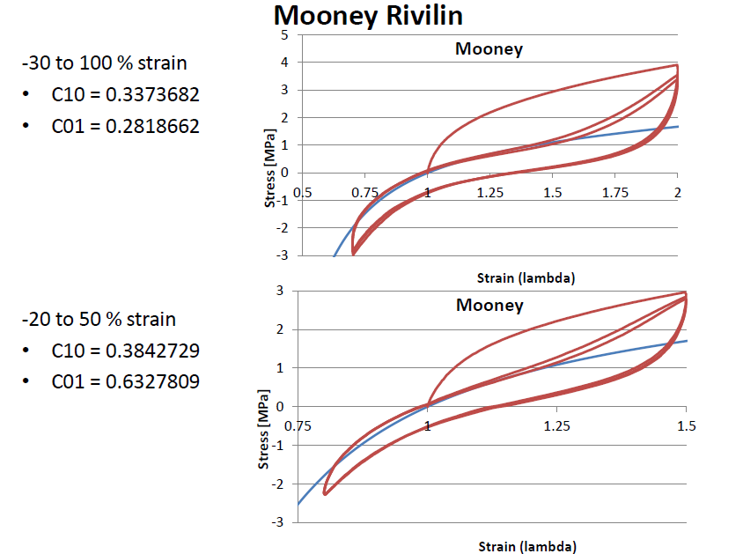

## Transfer test data into Abaqus

The test data of frequency dependent elastic modulus should be transferred to Abaqus format, where the frequency domain response can alternatively be defined in tabular form by giving the real and imaginary parts of http://50.16.225.63/v2016/books/usb/graphics/usb_eqn02817.gif—where http://50.16.225.63/v2016/books/usb/graphics/usb_eqn00391.gif is the circular frequency—as functions of frequency in cycles per time. Given the frequency-dependent storage and loss moduli http://50.16.225.63/v2016/books/usb/graphics/usb_eqn02808.gif, http://50.16.225.63/v2016/books/usb/graphics/usb_eqn02809.gif, the real and imaginary parts of http://50.16.225.63/v2016/books/usb/graphics/usb_eqn02817.gifare then given as

http://50.16.225.63/v2016/books/usb/graphics/usb_eqn02821.gif

where http://50.16.225.63/v2016/books/usb/graphics/usb_eqn02814.gif is the long-term shear modulus determined from the elastic or hyperelastic properties[1]. With previously tested data of Mooney-Rivlin parameters, the long-term shear modulus is calculated to be

 .

The shear modulus can be calculated from elastic modulus

,

where ν is Poisson’s ratio. According to classic elasticity, ν can be derived using Lamé’s relation

 .

The attached excel file, *Rubber data to ABQ from Risø (F8444-B466-B659-Q8034).xls*, in the appendices shows detailed conversion of data. In this file, the Poisson’s ratio ν was assumed to be 0.5 according to missed information of Bulk modulus. Now, we can get the value of Bulk modulus and calculate the proper Poisson’s ratio. See Section 1.2.3.

# Rubber analysis at GN

It is expensive to have all rubber material tested by a laboratory, if there are hundreds of material to be tested. We could actually do a pretest at GN to select the interested rubber, and then send them to a laboratory to get full test data.

For a new rubber material, the pretest is to vibrate the rubber with a mass load and measure the vibration velocities. The experimental setup will be represented in an Abaqus model. By adjusting the material properties of the rubber in the Abaqus model, we make a curve fit of the simulated velocity and measured. Therefore, the final adjusted material properties are what we get for the rubber.

According to our experimental equipment, we can make simple tension/compression test. That is to mold the rubber to a simple structure, e.g. a tube, and shake it together with a mass load at the other end of the tube. See Figure 1. The shaker vibrats in the vertical direction, which moves the base up and down, and therefore, applys a bending vibration to the rubber tube. The base velocity and mass velocity are measured, respectively. The velocity are normalized by generator voltage, so that, the two measured velocities are in phase to input signal. Both the amplitude and phase angle of the velocities are recorded.

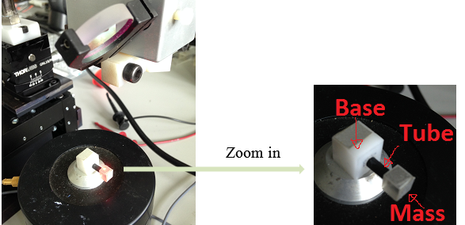

Figure 1 Experimental setup for rubber vibration

In the Abaqus model (see Figure 2), we set the rubber to be an elastic model, which uses the linear relationship between stress and strain. This is normally only valid for small strains, which is the case in hearing aids’ receiver suspension dynamic vibration. For an isotropic material, the elastic properties are defined by the Young’s modulus, E, and Poisson’s ratio, ν; while the viscoelastic damping is defined as a structure damping η. By adjusting the values of E, ν and η, we make a curve fitting to have the simulated velocity on mass align with measured data. The input signal of the Abaqus model is the measured base velocity.

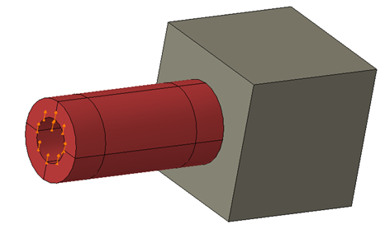

Figure 2 Abaqus model of the rubber vibration

Figure 3 shows a curve fitting of rubber vibration. With the curve fitting, the material properties of the rubber are obtained. The attached excel file, *Measure rubber tube vibration.xlsx*, in the appendices shows the measured and simulated data. In the future, the curve fitting should be done automatically in Isight using parametric optimization.

The material properties obtained in the pretest process is reliable for hearing stability models (dynamic vibration models). However, it is not good enough for large deformation cases, for instance, shrinkfit, shock protection, etc.. Anyway, we can use this process to slim the list of interested materials, and then, send the most interested material to a laboratory for full material test.

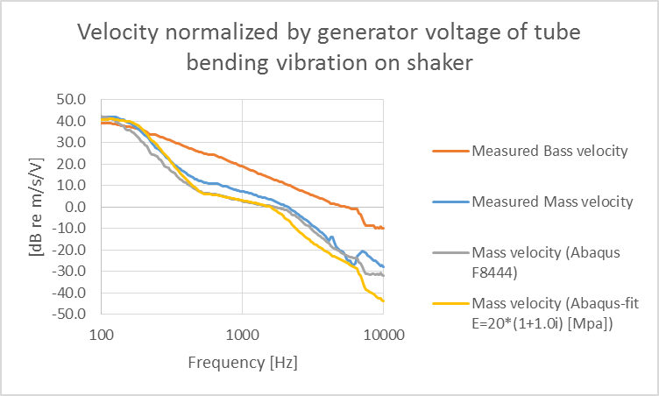

Figure 3 Curve fitting of velocities of rubber vibration

# Foam analysis

For foam dynamic modelling, we do similar process as for the rubber: the laboratory analysis and GN analysis. However, it is not good enough for impact modelling. The stiffness of foam (precisely open cell foam) differs with impact time. The impact period in our drop test of hearing aids is around 0.1 ms, while the fastest test period of laboratory, for instance, DatapointLab, is 1 ms (DIK cannot even do a test on foam). Although the data could be converted to any impact time using Time-Temperature Correspondence [2], the data is not precise enough. It has been test at GN that Abaqus impact models using the converted data does not give good agreement with experimental result. Therefore, we have to use equivalent material models for the Abaqus impact modelling. Moreover, the equivalent material properties can be measured on real hearing aid’s impact protection suspension system.

## Foam analysis by Laboratory

Foams are made up of polyhedral cells that pack in three dimensions. The foam cells can either be open or closed. Open cell foam is used in our hearing aids mainly for shock protection and sailing. For small strains (<5%) foam behave similarly (cell wall bending) for both compression and tension. However, at large strains the deformation mechanisms differ for compression (buckling and crushing) and tension (alignment and stretching) [2]. In hearing aids, compression of foam is more realistic. Material analysis is split to two parts: for dynamic vibration and for impact simulations. Details illustration of the tests can be found in the appendices, *Foam material determination for Abaqus model.pptx*.

### For dynamic vibration simulation

* Elasticity (Take a, b **and** c in the list below):

1. Uniaxial compression test data
2. Planar tension
3. Equibiaxial tension

* Viscoelastisity (Take a **or** b **or** c in the list below):

1. Relaxation test (Frequency-domain)
2. Creep test (Frequency-domain)
3. Frequency dependent complex Shear and Bulk module (Also called Storage and Loss module)

### For impact simulation

* Elasticity (Take a **or** b in the list below):

1. Uniaxial compression test data
2. Uniaxial compression test data (including load, unload, reload, unload…)

* Viscoelastisity (Take a **or** b in the list below):

1. Relaxation test (for required time rates)
2. Creep test (for required time rates)

### Laboratory report

Sections 3.1.1 and 3.1.2 show the ideal tests required for Abaqus modeling. When contacting to laboratories, not many can do the test. An American laboratory, DatapointLab, can do some of test. In the appendices, Datapointlab report.pdf is a report of Poron Foam from DatapointLab.

As mentioned previously, the data for dynamic vibration simulation is useful. However, the data for impact simulation is not precise. We will do an alternative test for the impact on real hearing aid’s suspension.

## Foam analysis at GN

For impact protection, foam is wrapped around receiver. In the FEA simulation, receiver-foam set can be treated as a mass-spring-damper system. The foam is simplified to be an equivalent linear elastic part. The elastic modulus and Reyleigh damping is adjusted by curve fitting to make the simulated data match the measured data.

The challenge of this material analysis is to make an experimental setup relative to real hearing aid drop test. In the following, we will illustrate the experimental setup, as well the curve fitting in Abaqus models. The measurement and simulation data can be found in the attached excel file, *Poron Impact v12(Actural B60 GD and Poron).xlsx*, in the appendices.

### Experimental setup

We will impact the test object (receiver wrapped by foam) using pendulum with an initial speed. With a given receiver-foam set (mass-spring-damper system), the key factors of impact is compression time, initial impact velocity.

#### Compression time

The foam compression time counts from the impact starting moment to the moment where maximum acceleration reaches. It is approximately half of the oscillation period. For open cell foam, the faster the foam is compressed, the harder the foam behaves. We need to make the compression time in the experimental setup to be similar as in hearing aids drop test.

An analysis shows that the compression time is independent to impact velocity. It is defined by foam structural stiffness and damping, and the receiver weight. See Figure 4.

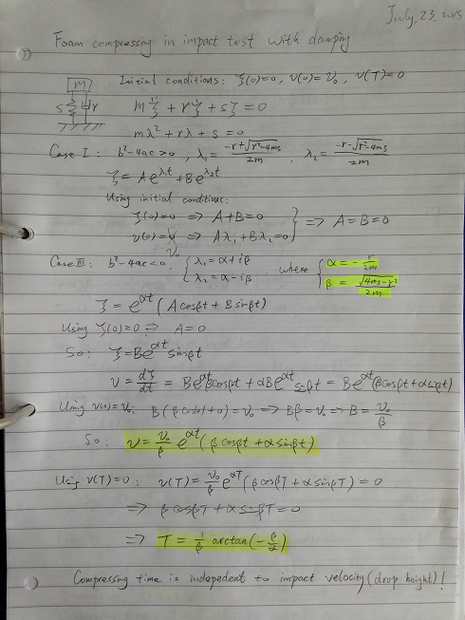

Figure 4 Analysis of compression time of a mass-spring-damper system.

This conclusion is supported by experimental data. The receiver wrapped by 0.5mm Poron foam is put on the ground of a mini pendulum. The pendulum started swing at three different height. Figure 5 shows the experimental setup to find compression time. The pendulum swang from different starting height, and impact the test object at the bottom position. The velocities on receiver surface are recorded by a laser vibrometer, and the impact force is measured by impedance head, which is bounded to the pendulum.

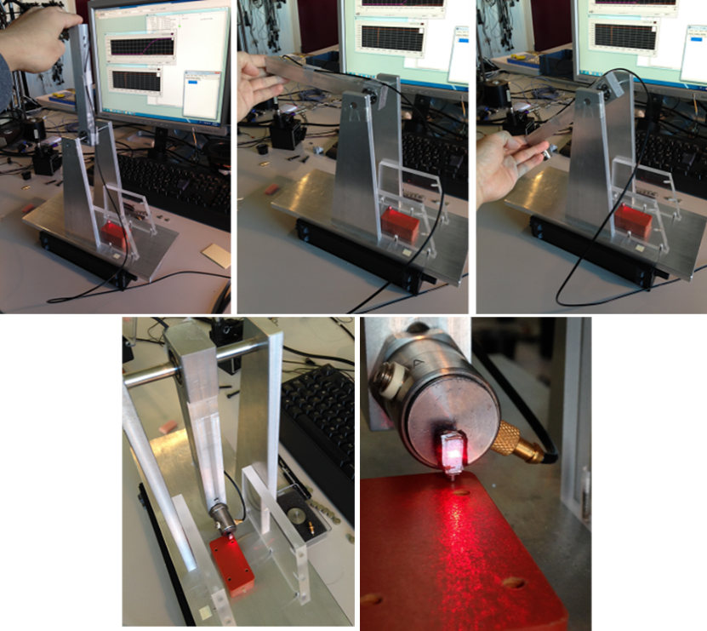

Figure 5 Experimental setup to find compression time

The measured velocities and force curves are shown in Figure 6. It can be clearly seen in the right sub-figure, where the velocities are normalized, that the compression time is the same, ~0.15 ms, regardless of initial impact velocities. This is true on condition that the foam is not compressed too much. If the foam has been compressed to large deformation, where the cell walls start crushing, structure stiffness shots to heaven. This could lead to huge G-force on receiver in impact. We should avoid compressing the foam to this condition. In other words, in hearing aid’s design we should keep the foam compressed in its “linear” deformation for the safety of receiver.

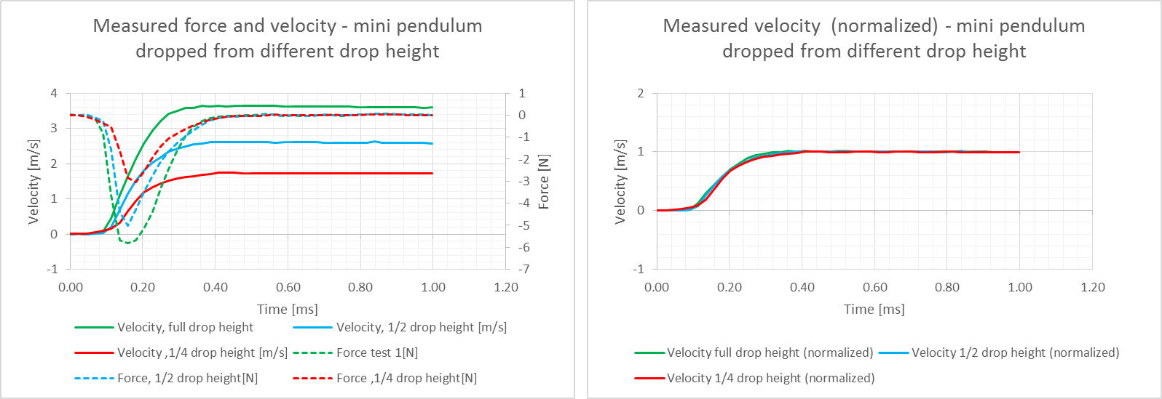

Figure 6 Measured impact velocity and force.

#### Impact velocity

The analysis in last section was based on the fact that the receiver-foam is impacted by the pendulum, which has an approximately constant travel velocity. However, in real hearing aids drop test, the pendulum impacts the housing shell of hearing aid. The receiver-foam set is impacted directly by frame surface, and therefore, the relative velocity between the receiver-foam and the frame is the impact velocity. This is difficult to measure, however, we can investigate approximately how much it is using Abaqus modelling.

The Abaqus model has pendulum traveling at 4427 mm/s towards hearing aid’s back. The mass of pendulum is infinitely large. See Figure 7.

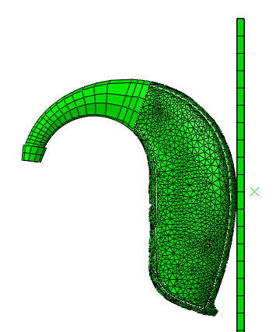

Figure 7 Abaqus model of hearing aid impact

The velocities on shell and frame, respectively, are obtained in the simulation at the positions shown in Figure 8, and the result is seen in Figure 9. It is obvious that the shell speed increase sharply in the impact; while the frame speed increase slower than that. This indicates the shell has the first protection for the structure inside when exposed to impact.

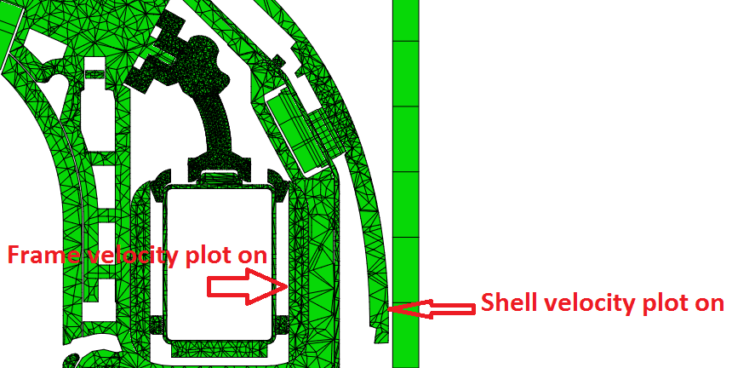

Figure 8 Positions where shell and frame velocity curves obtained

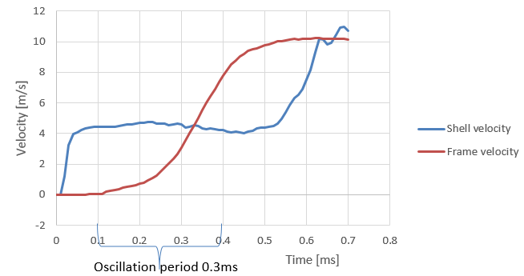

Figure 9 Shell velocity vs frame velocity

In the experimental setup, shell and frame are not included. Instead, a pendulum impacts the receiver-foam set. The speed of pendulum should be comparable to the frame velocity. Considering of the oscillation period of receiver-foam of 0.3 ms, the relative pendulum speed is the average value of frame speed from the impact starting time (0.1 ms) to 0.3 ms later. The frame speed after that period is still increasing, however there is not enough time for another oscillation period. Moreover, it increases slower than the previous period, which means it cannot compress the foam as much as the first period. In short, the frame velocity in of interest only for the time period 0.1 ms to 0.4 ms. The average frame speed is calculated to be 2.6 m/s. It is the pendulum velocity in experimental setup.

#### Measured velocity

The experimental setup is shown in Figure 10. Test object is GR receiver wrapped by 0.5mm Poron Foam. Pendulum swings from a starting point at height of 0.33 m, and impact the test object on its travelling at the lowest position. The pendulum speed at impact moment is  m/s.

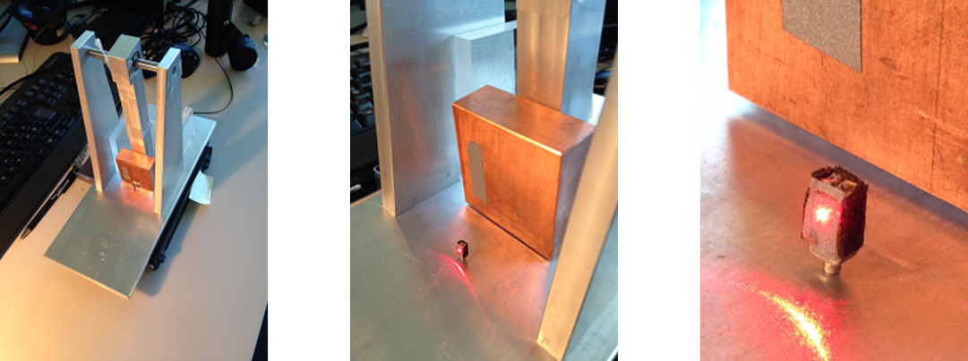

Figure 10 Experimental setup for impact test of foam

The measured velocity is then shown in Figure 11. The measurement were repeated three time, and stable results had been obtained.

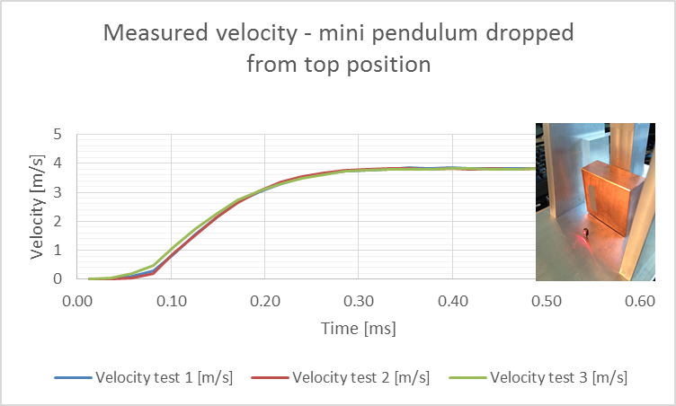

Figure 11 Receiver velocity measured using laser vibrometer under impact of pendulum speed of 2.6 m/s.

### Abaqus model - curve fitting

In Abaqus model, the receiver-foam system is simulated, and a pendulum is travelling at 2.6 m/s to impact on foam. See Figure 12.

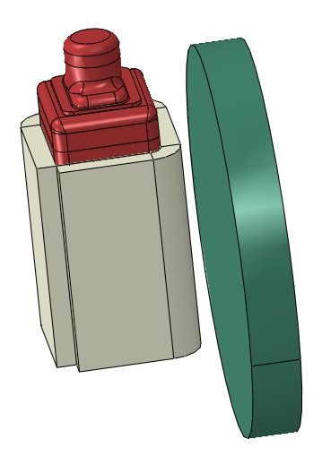

Figure 12 Abaqus model of receiver-foam impact.

The unknown parameters of the equivalent foam structure is elastic modulus E, Poisson’s ratio ν, and Reyleigh damping. The buckling of the cell walls of open cell foam does not result in any significant lateral deformation, and therefore, the Poisson’s ratio is close to zero in the equivalent material model. Reyleigh damping has two parts: α for mass proportional damping and β for stiffness proportional damping. The factor α stands for low frequency damping; while β is for high frequency damping. Since the impact period is less than 1 ms, which is higher than 1k Hz, we are dealing with high frequency case. Thereby, only the factor β should be considered. By curve fitting of trying different values of E and β, the best fit is obtained in Figure 13.

As mentioned in the first paragraph of section 3.1, foam compression differs from foam tension. According to the limitation of equivalent foam model, we can either focus on the foam compression or releasing period. The curve fitting focuses on the foam compression period, which is 0.15 ms. The maximum G-force on receiver happens at the end of foam compression period. What happens after this period is not of interest. As long as the equivalent foam structure represents this period, the whole impact model is reliable.

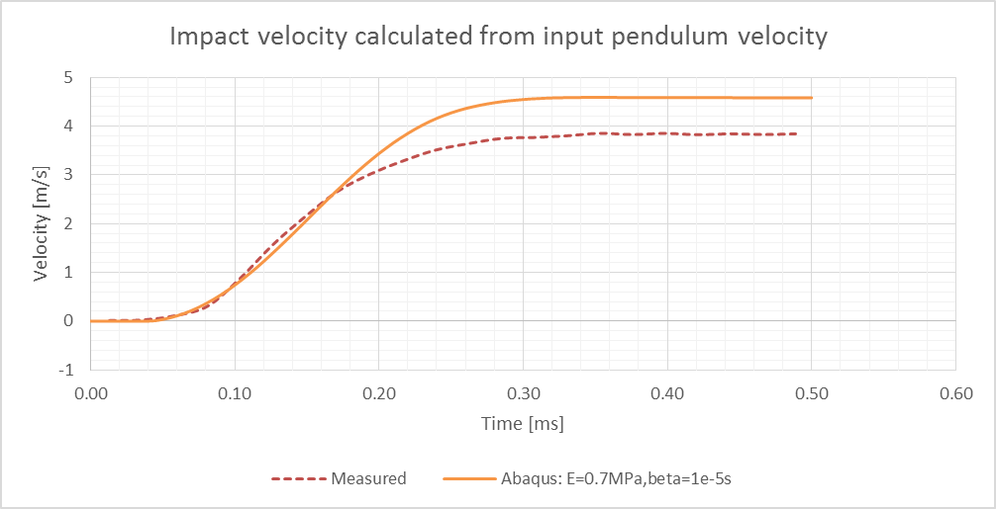

Figure 13 Curve fitting of impact velocity on receiver

# References

[1] Abaqus Analysis User's Guide 2016, 22.7.1 Time domain viscoelasticity

[2] Modeling Rubber and Viscoelasticity with Abaqus, 6.14, Dassault Systemes.

# Appendices



